**Test Case** **0017**

**System:** VirtuCardsClient & VirtuCardsHost

**Description:** Tests that the timer works properly

**Severity:** 3

**Instructions**

**Test1**

1. Start VirtuCardClient application
2. Click the button labeled “Sign In”
3. Enter “virtucards01@gmail.com” into the text input labeled “Enter email…”
4. Enter “Testing1” into the text input labeled “Enter password…”
5. Press the button labeled “Login”
6. A window should appear saying “Login Success”
7. Press the OK button that appears on that window
8. Start a second VirtuCardHost application
9. Repeat steps 2-7, but use “virtucards02@gmail.com” as the email and use “Testing1” as the password.
10. Start VirtuCardHost application
11. Repeat steps 2-7 but on the VirtuCardHost application
12. The checkbox “Allow Host to Join” should be checked on the host
13. Select the “GoFish” option from the game choices dropdown
14. Press the Create Game button
15. On both VirtuCardClient applications enter the 6-character room code found on the host’s screen into the field labeled “Enter Code…”
16. Press the Join Game button on both clients
17. On the host side, press the settings button and check the enable timer.
18. Set the timer for 40 seconds.
19. Press the Start Game button on the host application

**Expected Result:** Both the host and the client who has the current turn should have timers displayed.

**Host’s Timer**

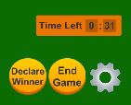

**Client 1’s Timer (properly hidden) Client 2’s Timer**

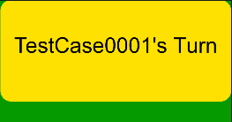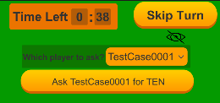

**Test2**

1. Start VirtuCardClient application
2. Click the button labeled “Sign In”
3. Enter “virtucards01@gmail.com” into the text input labeled “Enter email…”
4. Enter “Testing1” into the text input labeled “Enter password…”
5. Press the button labeled “Login”
6. A window should appear saying “Login Success”
7. Press the OK button that appears on that window
8. Start a second VirtuCardHost application
9. Repeat steps 2-7, but use “virtucards02@gmail.com” as the email and use “Testing1” as the password.
10. Start VirtuCardHost application
11. Repeat steps 2-7 but on the VirtuCardHost application
12. The checkbox “Allow Host to Join” should be checked on the host
13. Select the “GoFish” option from the game choices dropdown
14. Press the Create Game button
15. On both VirtuCardClient applications enter the 6-character room code found on the host’s screen into the field labeled “Enter Code…”
16. Press the Join Game button on both clients
17. On the host side, press the settings button and check the enable timer.
18. Set the timer for 40 seconds.
19. Press the Start Game button on the host application

**Expected Result:** Once the timer hits 30 seconds, it should turn red, and a message should appear beneath it with a message: “Warning only 30 seconds”

**Timer before the 30 second warning**



**Timer after the 30 second warning**

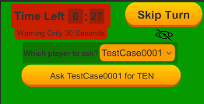

**Test3**

1. Start VirtuCardClient application
2. Click the button labeled “Sign In”
3. Enter “virtucards01@gmail.com” into the text input labeled “Enter email…”
4. Enter “Testing1” into the text input labeled “Enter password…”
5. Press the button labeled “Login”
6. A window should appear saying “Login Success”
7. Press the OK button that appears on that window
8. Start a second VirtuCardHost application
9. Repeat steps 2-7, but use “virtucards02@gmail.com” as the email and use “Testing1” as the password.
10. Start VirtuCardHost application
11. Repeat steps 2-7 but on the VirtuCardHost application
12. The checkbox “Allow Host to Join” should be checked on the host
13. Select the “GoFish” option from the game choices dropdown
14. Press the Create Game button
15. On both VirtuCardClient applications enter the 6-character room code found on the host’s screen into the field labeled “Enter Code…”
16. Press the Join Game button on both clients
17. On the host side, press the settings button and check the enable timer.
18. Set the timer for 40 seconds.
19. Press the Start Game button on the host application

**Expected Result:** Once the timer reaches 0 seconds, it should restart at 40 seconds, and the client who had their timer displayed should have had their turn skipped and received a card.

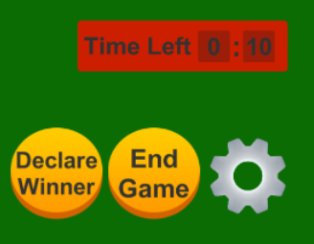**Host’s Timer Before Skip Host’s Timer After Skip**

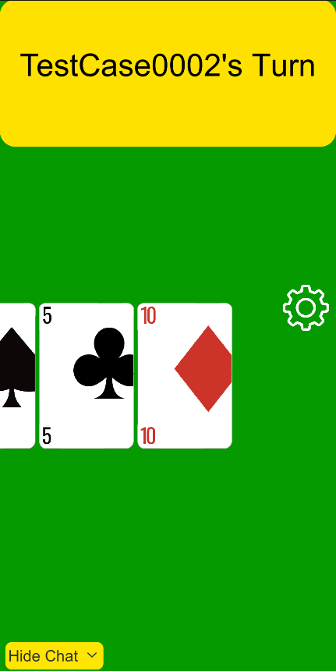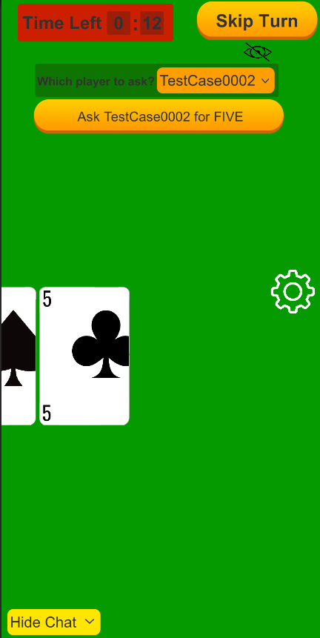 **Client 1 Before Timer Ran Out Client 1 After Timer Ran Out**

**Test4**

1. Start VirtuCardClient application
2. Click the button labeled “Sign In”
3. Enter “virtucards01@gmail.com” into the text input labeled “Enter email…”
4. Enter “Testing1” into the text input labeled “Enter password…”
5. Press the button labeled “Login”
6. A window should appear saying “Login Success”
7. Press the OK button that appears on that window
8. Start a second VirtuCardHost application
9. Repeat steps 2-7, but use “virtucards02@gmail.com” as the email and use “Testing1” as the password.
10. Start VirtuCardHost application
11. Repeat steps 2-7 but on the VirtuCardHost application
12. The checkbox “Allow Host to Join” should be checked on the host
13. Select the “GoFish” option from the game choices dropdown
14. Press the Create Game button
15. On both VirtuCardClient applications enter the 6-character room code found on the host’s screen into the field labeled “Enter Code…”
16. Press the Join Game button on both clients
17. On the host side, press the settings button and check the enable timer.
18. Set the timer for 40 seconds.
19. Press the Start Game button on the host application
20. Once the game has started, press the settings button on the host.
21. Uncheck the enable timer box.

**Expected Result:** The timer should disappear, and turns should not be skipped automatically.

**Before Disabling Timer**

**Host Client**

 

**After Disabling Timer**

**Host Client**

